B1 – 10mm Model Comparisons

Model: Force = c0 + c1(exp(1-erel))\*Pressure Force = c0 + c1 (1-Erel)\*Pressure

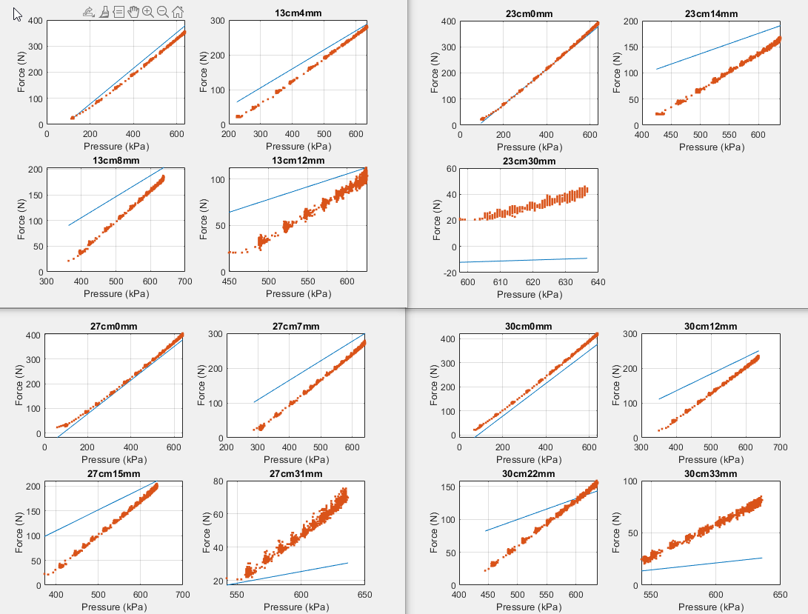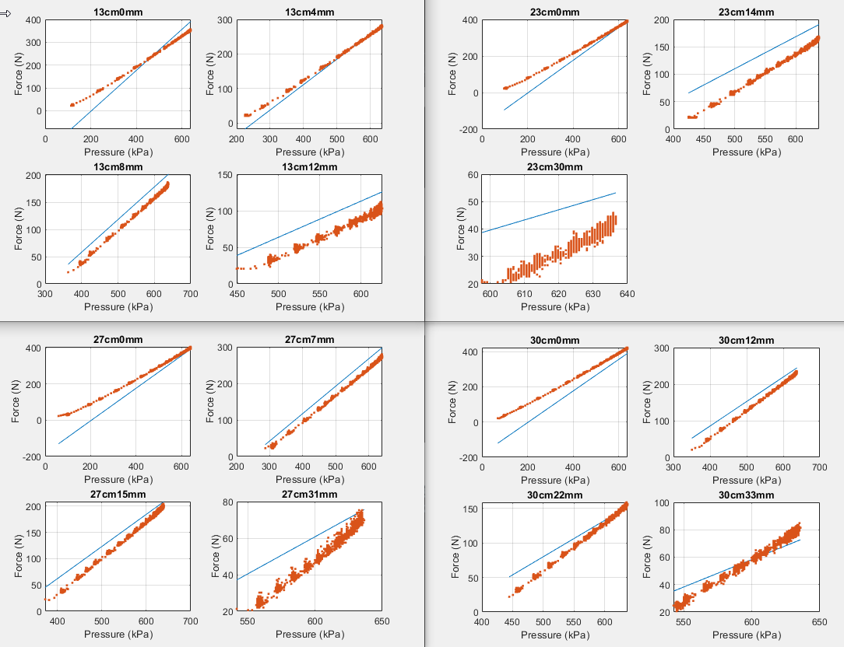

Force = c0 + c1(exp(-Erel))Pressure Force = c0 + c1(exp(-Erel^2))Pressure

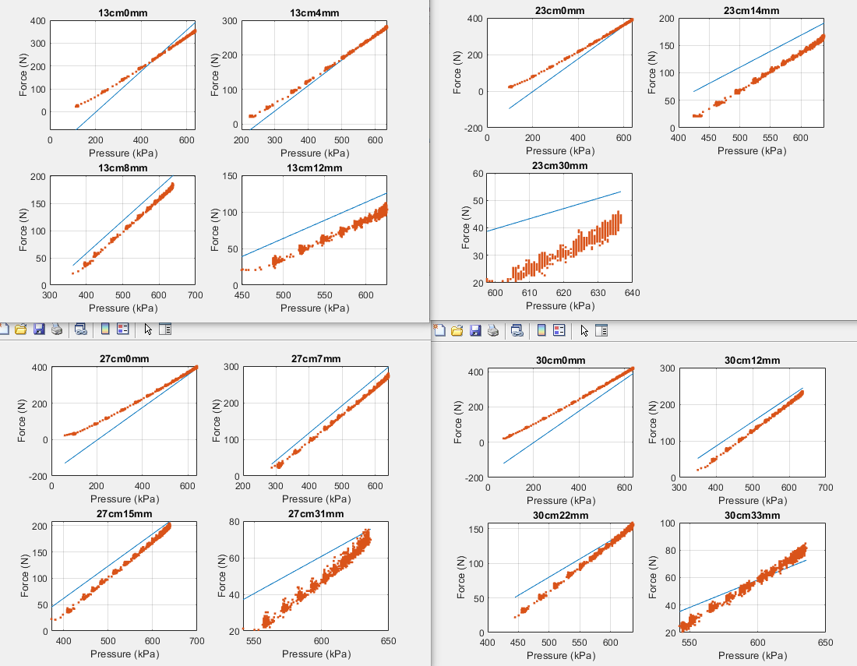

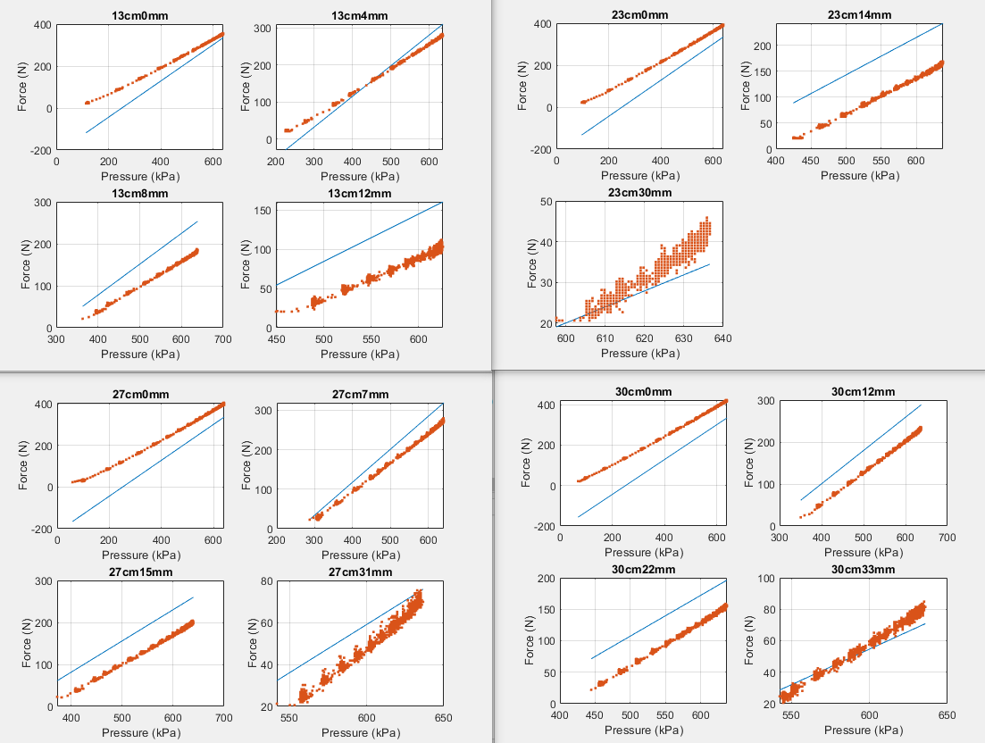

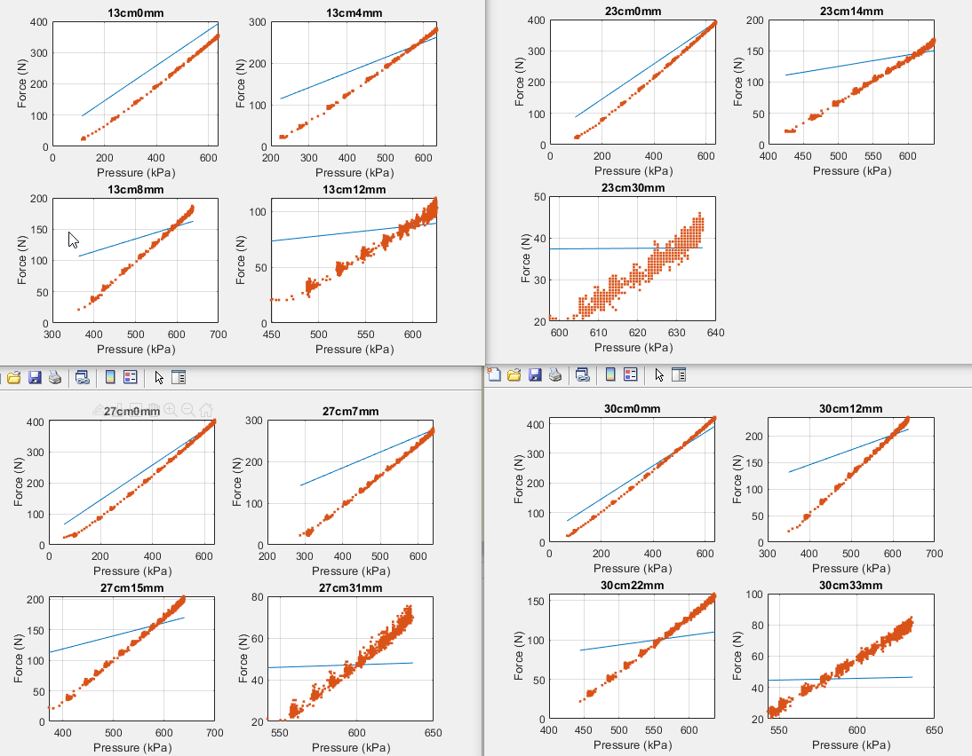Force = c0 + c1(1-Erel)^2Pressure Force = c0 + c1(1-Erel)